GITHUB 1: Getting Started

GITHUB is a file management system that does the following:

- Keeps your files in the cloud.
- Easily maintains different versions of your code.
- Great for collaboration, keeps track of everyone’s changes!

We will use Github to manage the lecture files.

Step 0: Basic Setup (only do once)

- Open a Github account by going to “github.com”. Try to register with your Emory email since you sometimes get student benefits. Be careful selecting your username, this will be visible to the public.

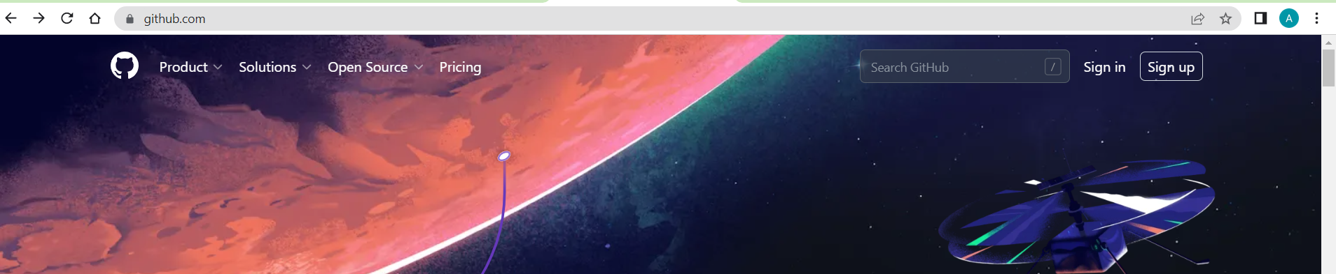

- Download Github Desktop from: https://desktop.github.com/

Follow the default options in the installation process and use your newly created Github credentials.

Step 1: Adding Lecture Notes to your account (only do once)

- Sign-in to “Github.com” using your account credentials.
- Go the website of the repository with the lecture notes:

https://github.com/alejandrosanchezbecerra/datasci530fall2025

- Click on the “Fork Button” in the top-right corner:

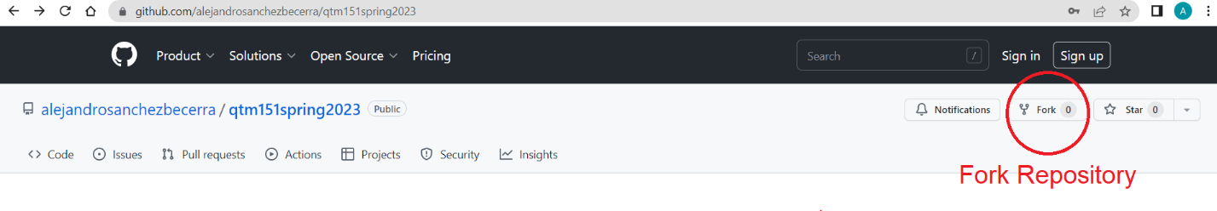
- You will be asked to make your own copy of the lecture notes. You can add any name you like. I recommend you use the name same name I used for the repository

Step 2: Downloading Lectures to your Computer (only do once)

- Open Github Desktop
- Click on the “File” tab. Select the option “Clone repository”. Choose the repository you want to clone. In this case it would be the “datasci530” repository we just forked.

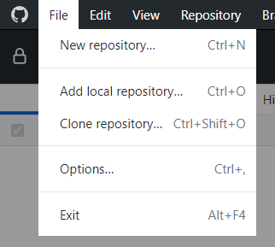

Notes:
- The local path is where you want to store the repository on your computer.
- Avoid storing in a subfolder of another file sharing system, e.g. “One-Drive” or “Dropbox”. Sometimes this can cause issues.
- Try to store the folder “datasci530” in the same location where you save the files for your other classes (as an example, I used the Emory subfolder in the Documents folder). You will need to access the datasci530 folder often during this class, make sure you know where you’re saving it!

- In the next page, SELECT the option “To contribute to the parent project”. See next picture.

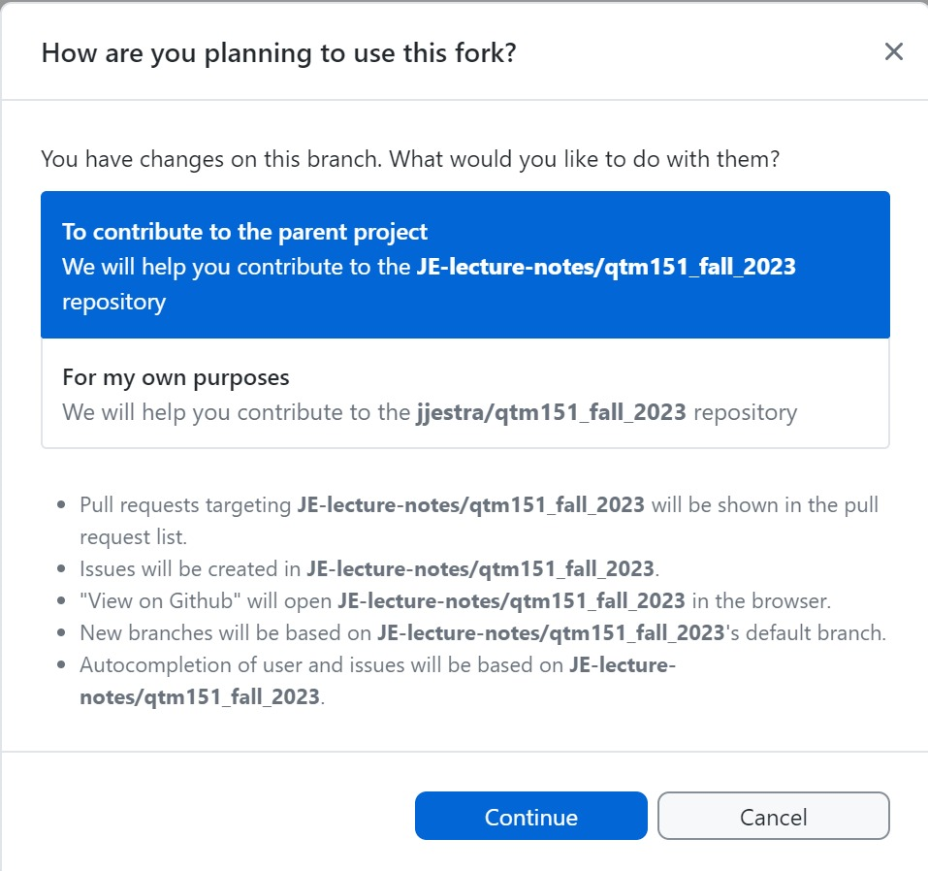

Notes:
- This option allows you to keep updating your lecture notes from the instructor’s repository.
- The other option creates a local copy that has no links to the original repository. If you accidentally choose this option, you won’t be able to see any changes. To reverse: (a) remove the repository on your computer (by right-clicking on the repository on Github dekstop), (b) manually delete the directory, (c) go back to Step 2.

You’re done! You should have access to the lecture notes.

These notes will be updated constantly! Check the next manual on how to update a repository.

